Is it Time to Give Your Dog A Bath?
Drs. Foster & Smith Educational Staff
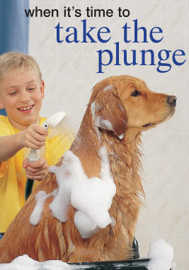
Trying to decide when and how to bathe your dog is often difficult. This is because bathing frequency depends on a number of factors: the particular breed of dog, how much time is spent outdoors, the dog's age, and any existing medical conditions, to name a few.
The fact is that when and how you bathe your dog will change throughout the year and throughout the dog's life. Here are some reasons that your dog may need a bath, as well as some bathing pointers:
1. The dog rolled in something and smells.
Pretty obvious right? This is actually the #1 reason most dogs are bathed. If your dog has a habit of seeking out something smelly and rolling in it, then he will need a bath right away. Use a good strong shampoo like the Deodorizing Dog Shampoo and don't be afraid to wash him twice.
2. The dog has a doggy smell.
An odor on the coat can often be traced to a problem with the ears, mouth, feet, or anal glands. An odor coming from the skin is often a sign of disease, such as a yeast infection. Any dog with more than a "doggy" smell should be checked by a veterinarian. For dogs with a simple doggy odor, choose a general shampoo, such as Deodorizing Dog Shampoo.
3. The dog has dandruff.
Dandruff may be caused by dry, irritated, or oily skin, but all of these conditions can be helped by the appropriate shampoo and a good bathing. Check with your veterinarian or groomer to determine the cause of your dog's skin condition and then choose the right shampoo.
4. The dog has allergies.
Bathing a dog with itchy skin from allergies can be soothing and help reduce itching. In most cases, a soothing oatmeal shampoo, or a gentle hypo-allergenic or hydrocortisone-based shampoo should be used.
5. The dog has fleas, mites, or lice.
Shampooing is still one of the best ways to get rid of external parasites. Make sure to work with your veterinarian and get the appropriate diagnosis and corresponding treatment.
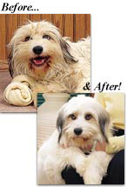
Once you determine the primary purpose for the shampoo you will need - for instance, if your dog always gets an unpleasant doggy odor three weeks after bathing - then choose an appropriate shampoo and have it on hand for when you need it. Use our Shampoo Comparison Chart for help in choosing the right shampoo for your dog.
A few other tips to remember about bathing. . .
- Always use a shampoo formulated for dogs. Human shampoos have a different pH level and often use harsher detergents than pet shampoos. You can do more damage than good if you use a human shampoo on pets. After shampooing, rinse very thoroughly. Shampoo residue can be very irritating to your pet's skin.
- Start bathing your dog when he or she is young so bath time will be easier as your dog ages.
- Brushing is one of the best ways to take care of your dog's skin and coat and in many cases is more important than bathing. Brushing and removing mats should always be done before the bath.
- Fatty acid supplements added to your pet's good diet will help maintain a healthy haircoat and skin. For the best coats, we recommend daily brushing, regular baths, and supplementation with a fatty acid supplement like Vitacoat® Plus.
Every dog needs a bath from time to time so follow your instincts - and these tips - and your dog and your family will thank you for it.

